**Assignment -3**

Cloud Object Storage and Watson Assistant

|  |  |
| --- | --- |
| Assignment Date | 12 Nov 2022 |
| Student Name | S. Bharanidhar |
| Team ID | PNT2022TMID30065 |
| Maximum Marks | 2 Marks |

**Question-1:**

Create a Bucket in IBM object storage

**Solution:**

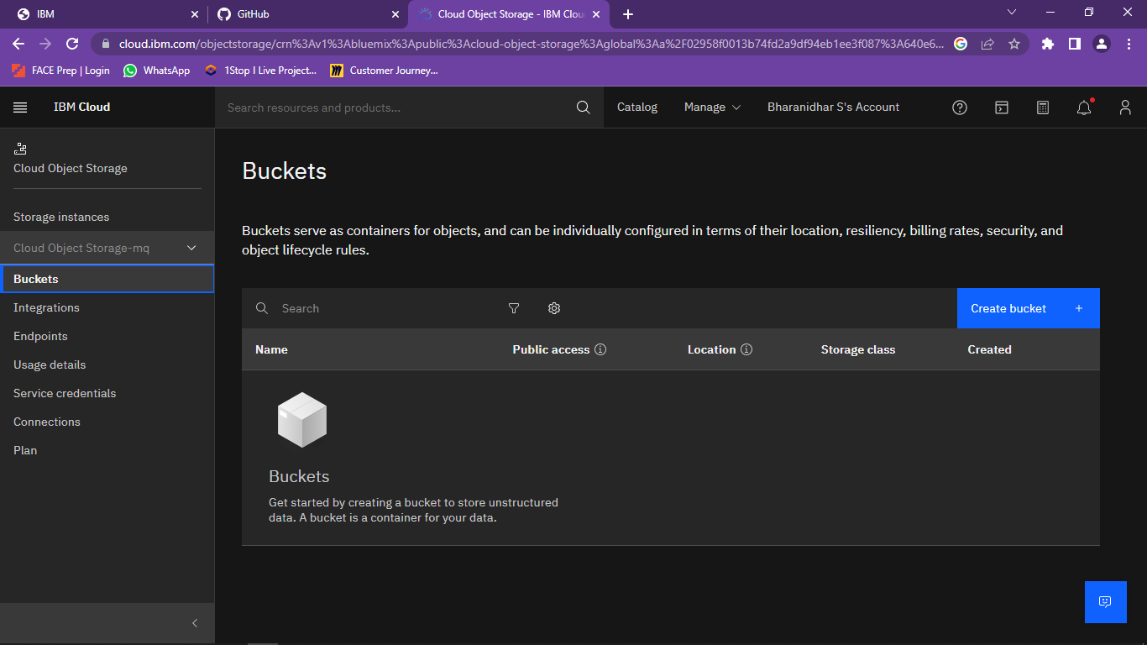

**Question-2:**

Upload an 5 images to ibm object storage and make it public. write html code to displaying all the 5 images.

**Solution:**

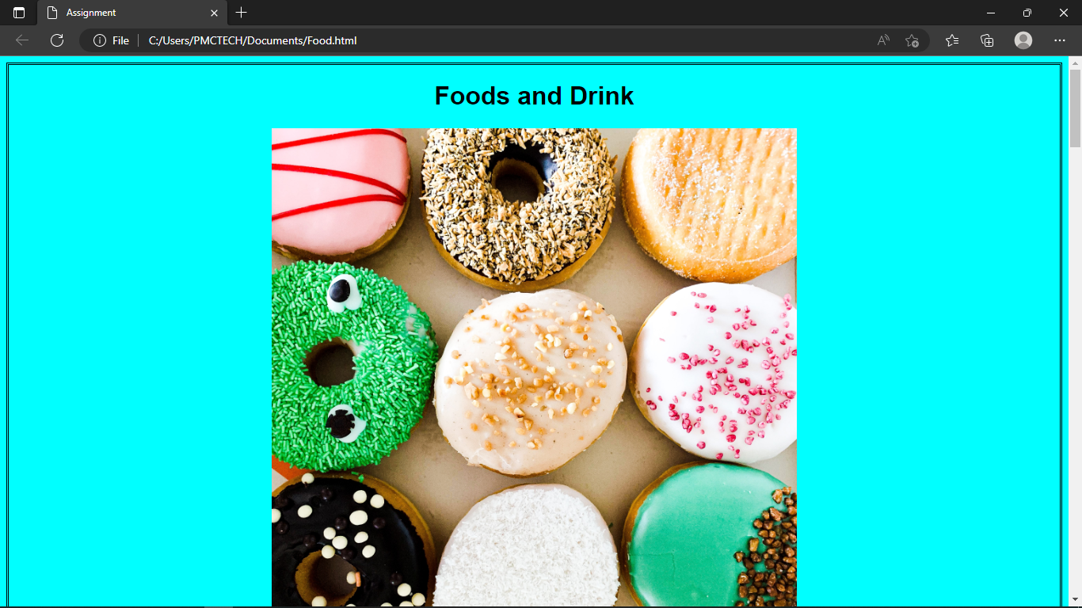

**HTML CODE:**

<!DOCTYPE html>

<title>Assignment</title>

<head> <style> img{ display: block; margin-left: auto; margin-right: auto; border: aqua; width: 50%;

}

Body{

style="border:rgb(15, 15, 15); border-width:5px;

border-style:double;text-align: center;font-family: Arial, Helvetica, sans-serif; background-color:green"

}

</style>

</head>

<body style="background-color: green;">

<h1>Skill/Job Recommender</h1>

<img src="https://s3.jp-tok.cloud-object-storage.appdomain.cloud/test02313/WhatsApp Image 2022-

11-12 at 2.51.42 PM (1).jpeg" alt="Green" style="width:50%" >

<br>

<img src="https://s3.jp-tok.cloud-object-storage.appdomain.cloud/test02313/WhatsApp Image 2022-

11-12 at 2.51.42 PM (2).jpeg" alt="Green" style="width:50%" >

<br>

<img src="https://s3.jp-tok.cloud-object-storage.appdomain.cloud/test02313/WhatsApp Image 2022-

11-12 at 11.19.11 (1).jpeg" alt="Green" style="width:50%" >

<br>

<img src="https://s3.jp-tok.cloud-object-storage.appdomain.cloud/test02313/WhatsApp Image 2022-

11-12 at 2.51.42 PM.jpeg" alt="Green" style="width:50%" >

<br>

<img src="https://s3.jp-tok.cloud-object-storage.appdomain.cloud/test02313/WhatsApp Image 2022-

11-12 at 2.51.43 PM.jpeg" alt="Green" style="width:50%" >

</body>

</html>

**Question-3:**

Upload a css page to the object storage and use the same page in your HTML code.

**Solution:**

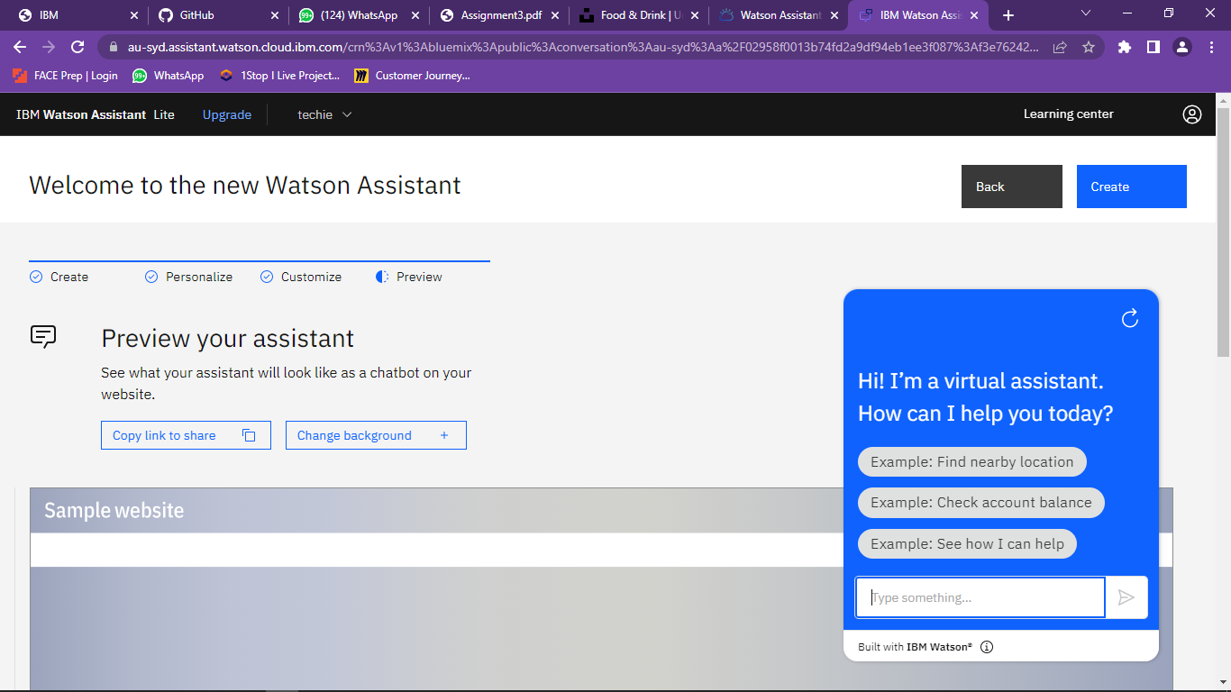

**Question-4:**

Design a chatbot using IBM Watson assistant for hospital. Ex: User comes with query to know the branches for that hospital in your city. Submit the web URL of that chat bot as a assignment.

**Solution:**

**URL:**

https://web-chat.global.assistant.watson.appdomain.cloud/preview.html?backgroundImageURL=https%3A%2F%2Fau-syd.assistant.watson.cloud.ibm.com%2Fpublic%2Fimages%2Fupx-f3e76242-bfd1-4c25-a7a6-7dc18eb5263d%3A%3Afe90263b-dc16-49c6-8dbf-db939273f0f9&integrationID=e1bd9d83-9343-46ef-a44d-5bb69d4761cb&region=au-syd&serviceInstanceID=f3e76242-bfd1-4c25-a7a6-7dc18eb5263d

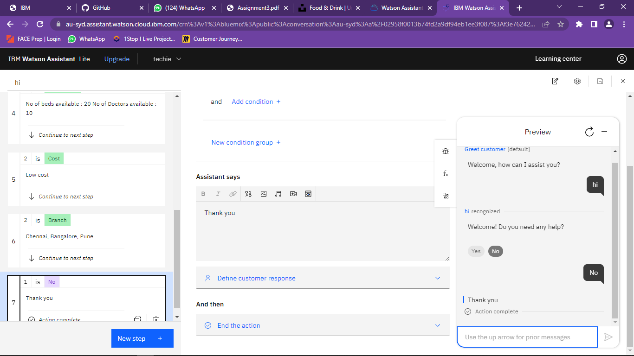

**Question-5:**

Create Watson assistant service with 10 steps and use 3 conditions in it. Load that script in HTML page .

**Solution:**

<!DOCTYPE html>

<html lang="en">

<head>

<meta charset="UTF-8">

<meta http-equiv="X-UA-Compatible" content="IE=edge">

<meta name="viewport" content="width=device-width, initial-scale=1.0"> <title>Hospital</title>

<style> body { font-family: Verdana, Geneva, Tahoma, sans-serif; background-color:rgb(241, 120, 128); font-size: 1.7rem; color: rgb(1, 22, 74);

} a { color: rgb(25, 52, 0); text-decoration: none;

}

h1{

text-shadow: 2px 2px 8px #C01986; background-image:"C:\Users\G RENUKA DEVI\OneDrive\Desktop\healthcare-technology-doctor-using-digital-tablet-iconmedical-network-hospital-background-162019727.jpg"; background-repeat:no-repeat;

background-size: cover;

}

a:hover {

color: rgb(0, 29, 1); padding: 5px 20px;

background-color: #C8D40C; border-radius: 5px;

transition: .5s ease-in-out;

}

</style>

</head>

<body>

<center><br><br><br>

<h1>Apollo Hospital</h1><br>

<a

hrefhttps://web-chat.global.assistant.watson.appdomain.cloud/preview.html?backgroundImageURL=https%3A%2F%2Fau-syd.assistant.watson.cloud.ibm.com%2Fpublic%2Fimages%2Fupx-f3e76242-bfd1-4c25-a7a6-7dc18eb5263d%3A%3Afe90263b-dc16-49c6-8dbf-db939273f0f9&integrationID=e1bd9d83-9343-46ef-a44d-5bb69d4761cb&region=au-syd&serviceInstanceID=f3e76242-bfd1-4c25-a7a6-7dc18eb5263d"> Click here for assistance </a>

<img src="C:\Users\PMCTECH\Downloads\plus.webp ">

</center> <script> <script>

window.watsonAssistantChatOptions = {

integrationID: "e1bd9d83-9343-46ef-a44d-5bb69d4761cb", // The ID of this integration.

region: "au-syd", // The region your integration is hosted in.

serviceInstanceID: "f3e76242-bfd1-4c25-a7a6-7dc18eb5263d", // The ID of your service instance.

onLoad: function(instance) { instance.render(); }

};

setTimeout(function(){

const t=document.createElement('script');

t.src="https://web-chat.global.assistant.watson.appdomain.cloud/versions/" + (window.watsonAssistantChatOptions.clientVersion || 'latest') + "/WatsonAssistantChatEntry.js";

document.head.appendChild(t);

});

</script>

</body>

OUTPUT:

